[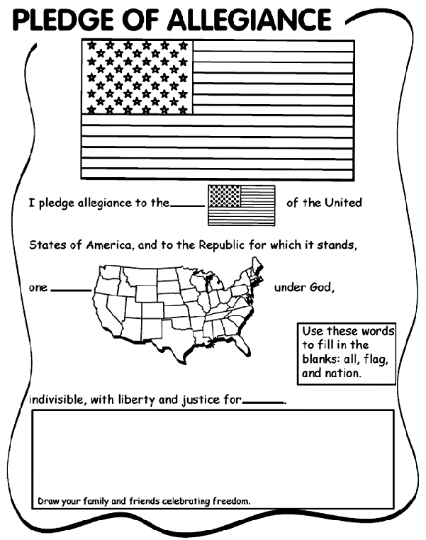](http://www.google.com/url?sa=i&rct=j&q=&esrc=s&frm=1&source=images&cd=&cad=rja&docid=lLJvDSWGkl9NZM&tbnid=BIqAfrCGytb_pM:&ved=0CAUQjRw&url=http%3A%2F%2Fwww.crayola.com%2Ffree-coloring-pages%2Fprint%2Fpledge-of-allegiance-coloring-page%2F&ei=lTiBUcHQNOO52QWq2IHACw&bvm=bv.45921128,d.aWM&psig=AFQjCNE9pg8t0gKZANiaAAw7qptc26wxwQ&ust=1367509515266656)